HASHES

* A cryptographic hash function(CHF) is a mathematical algorithm that maps data to a bit array of a fixed size.
* Its is a one-way function, that is, a function, which is practically infeasible to invert.

HASH OF A FILE:

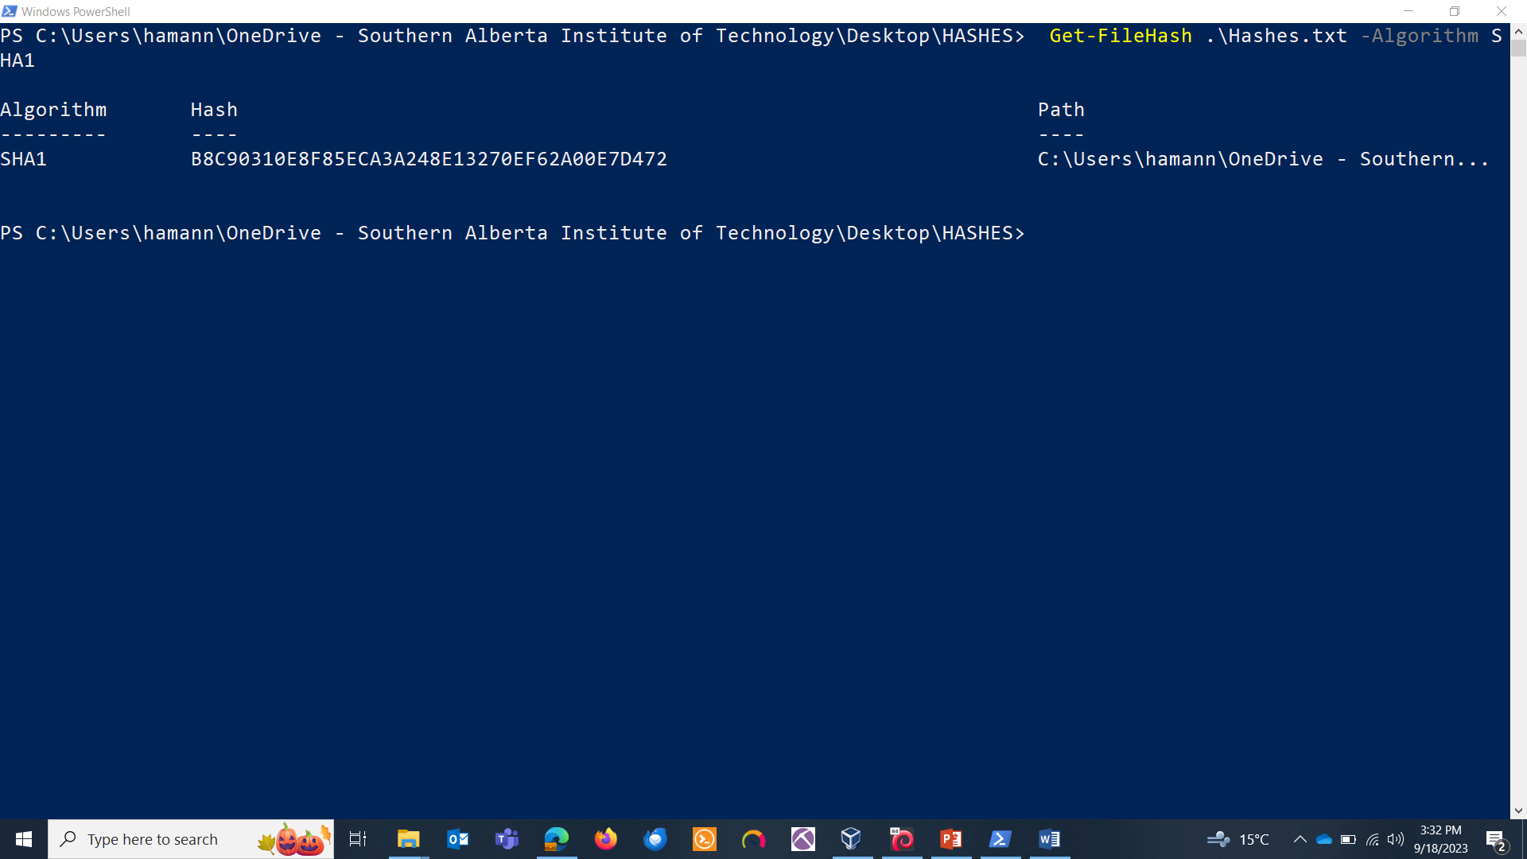

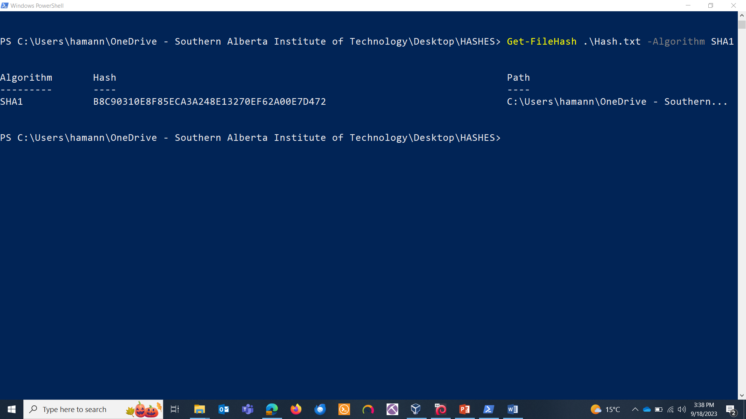

I changed the contents in the text file.

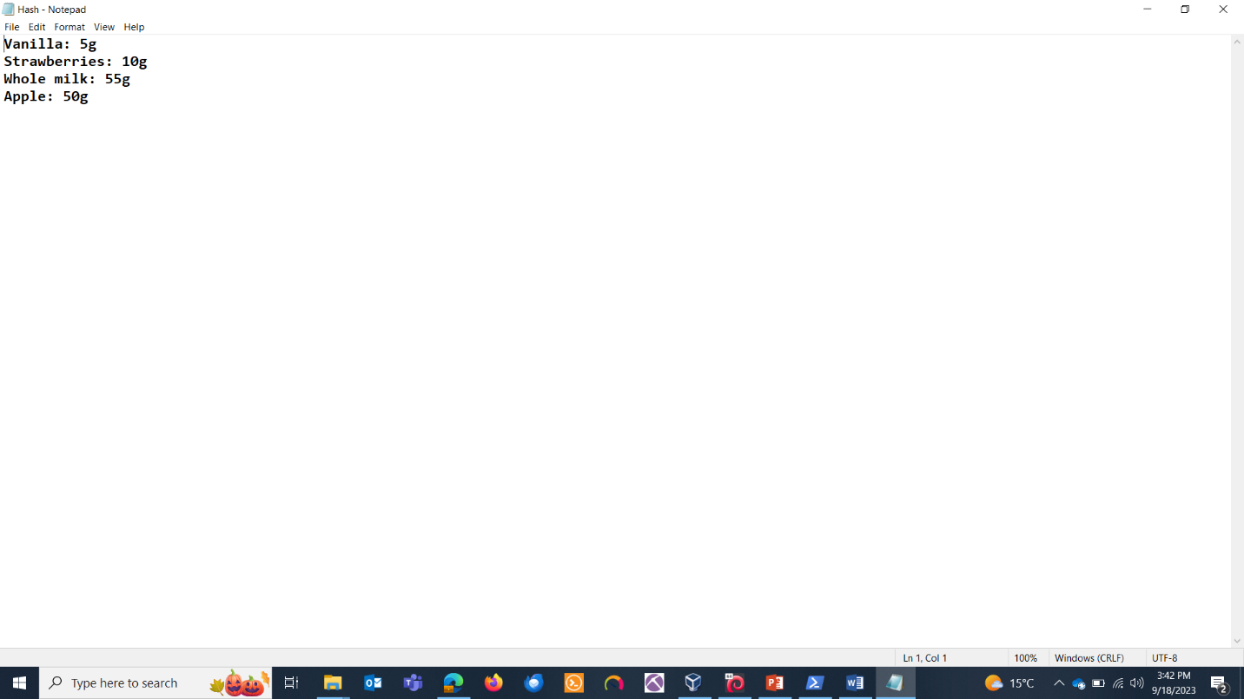

Hash is changed:

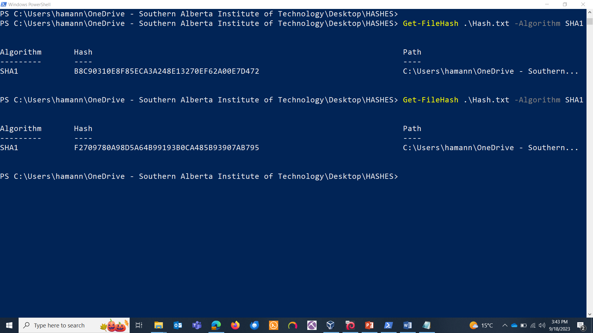

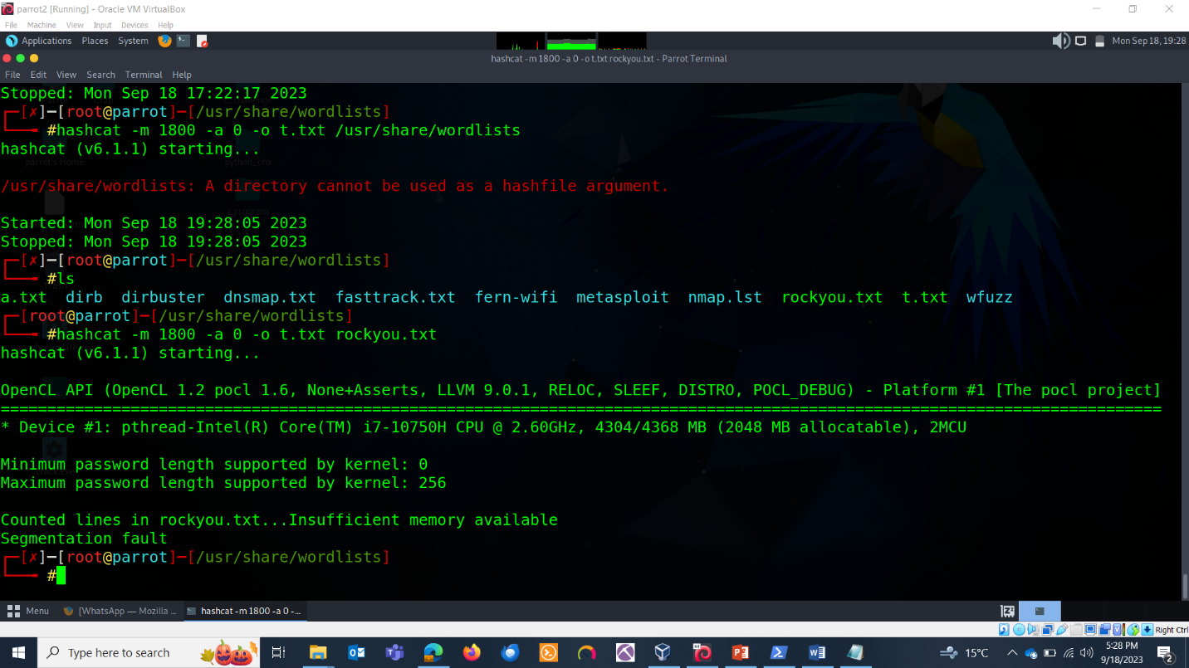

HASHCAT:

Hashcat –help

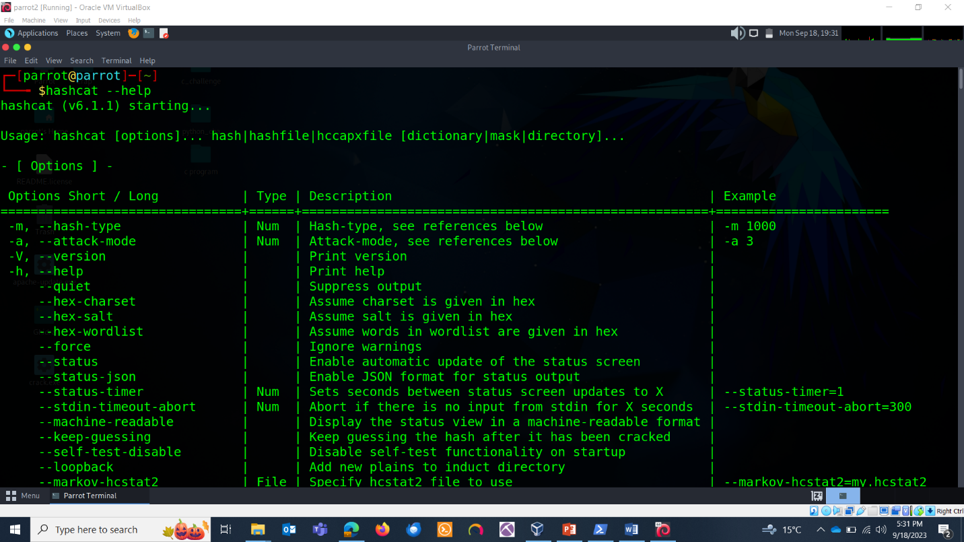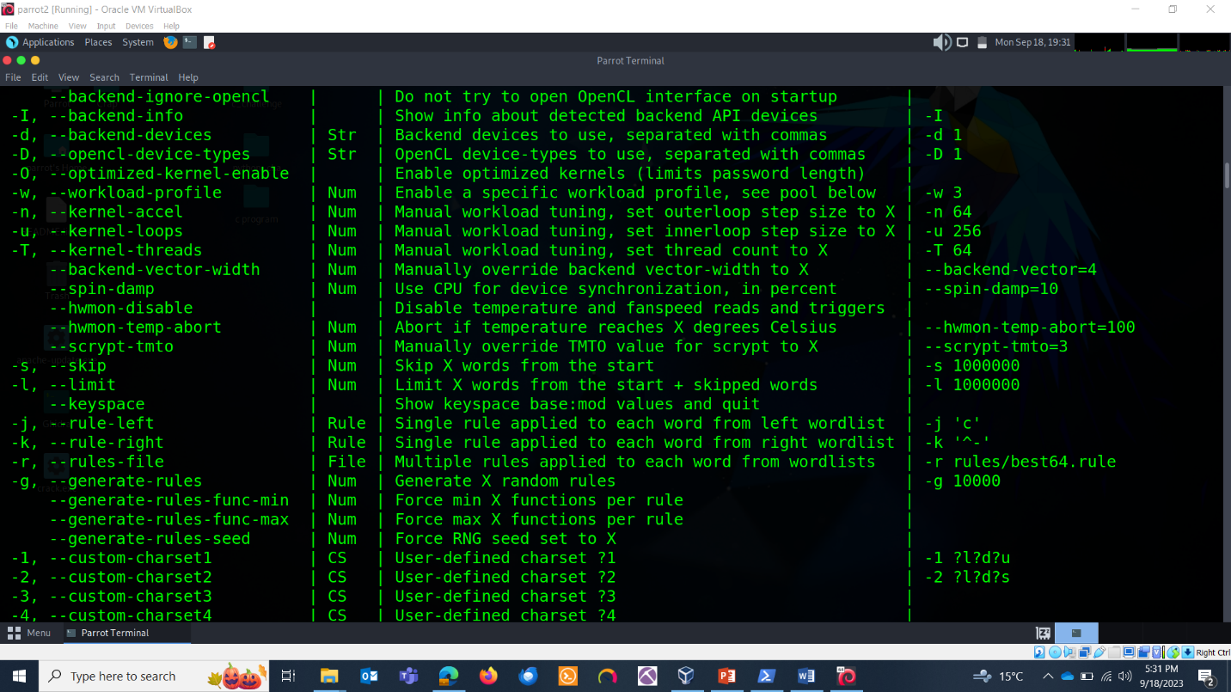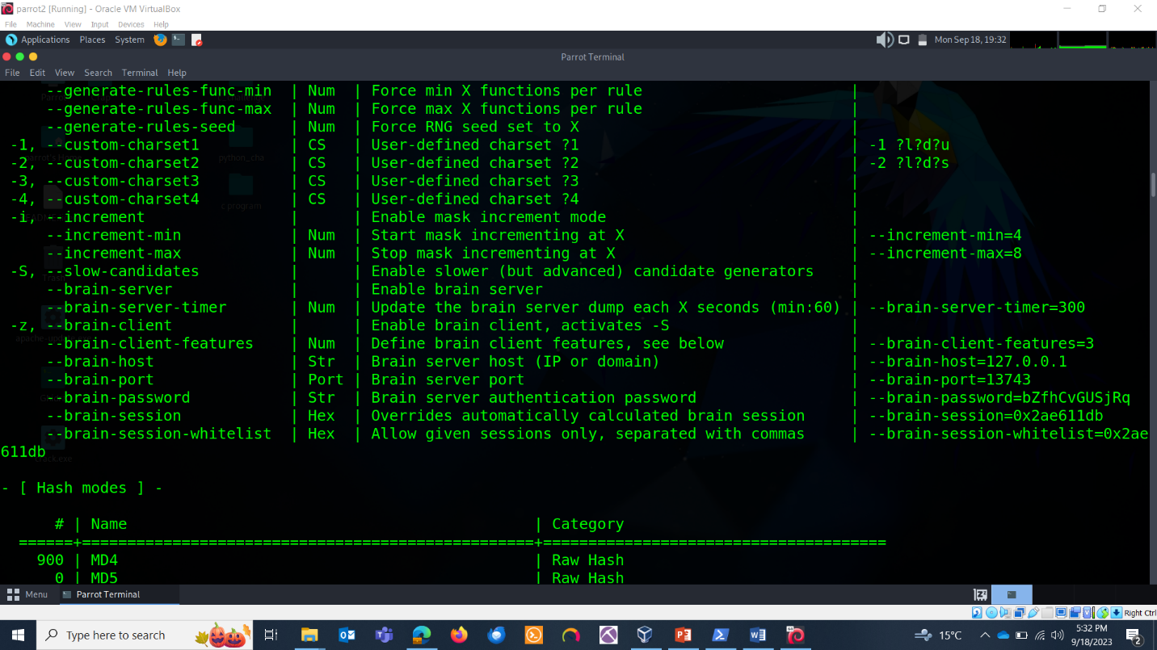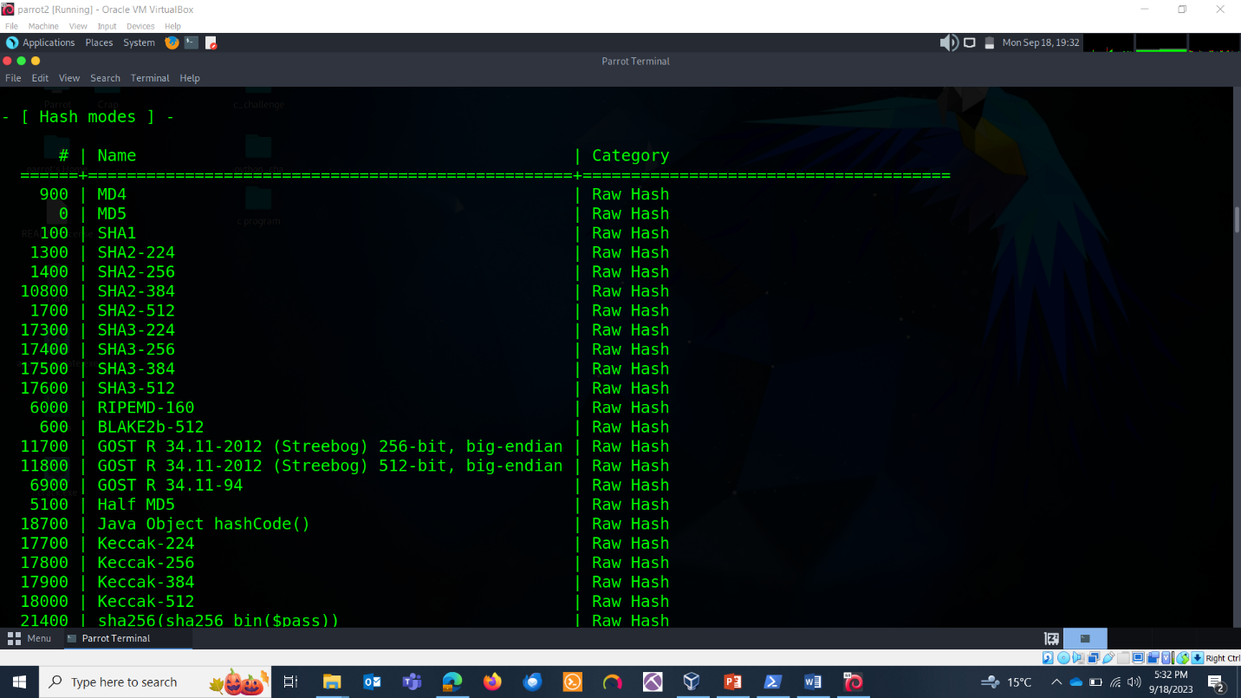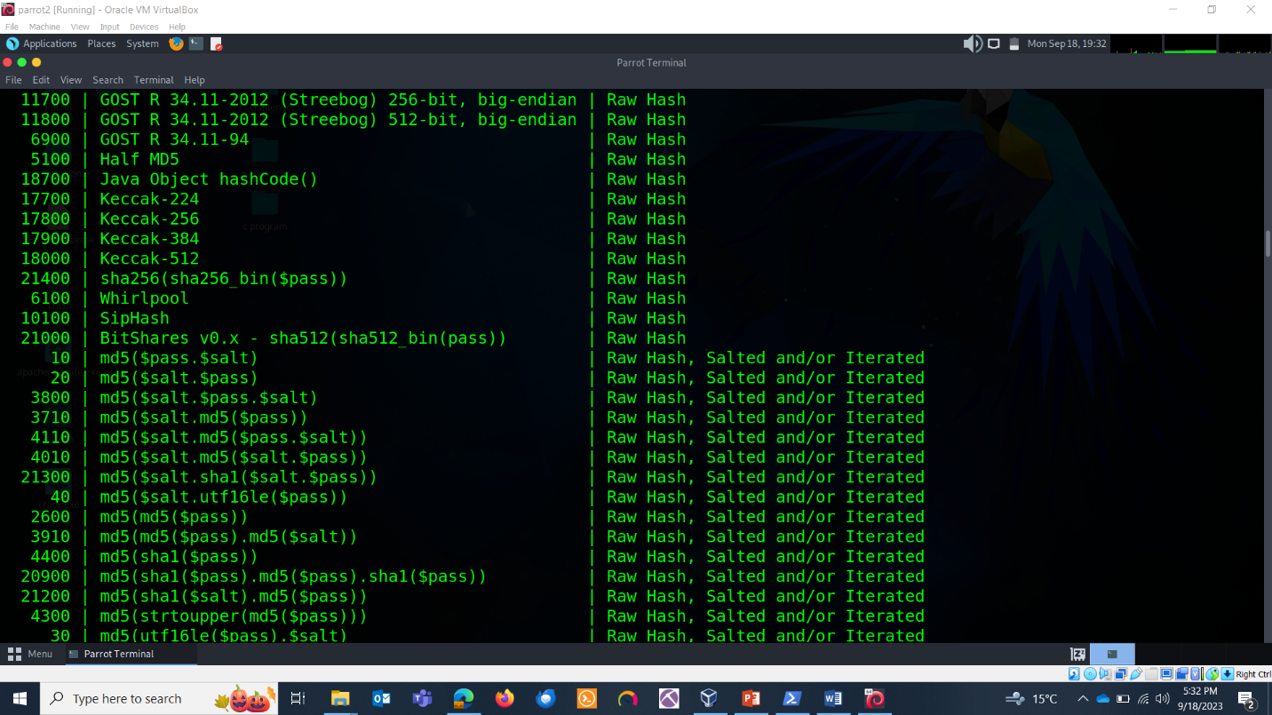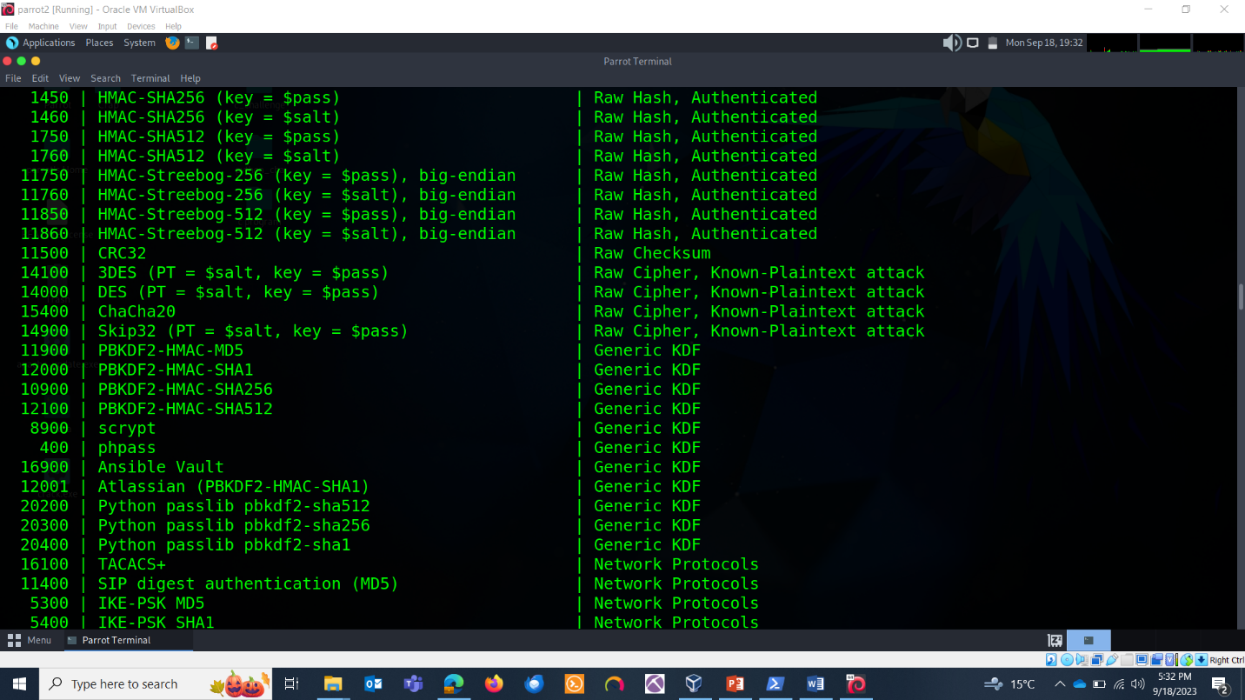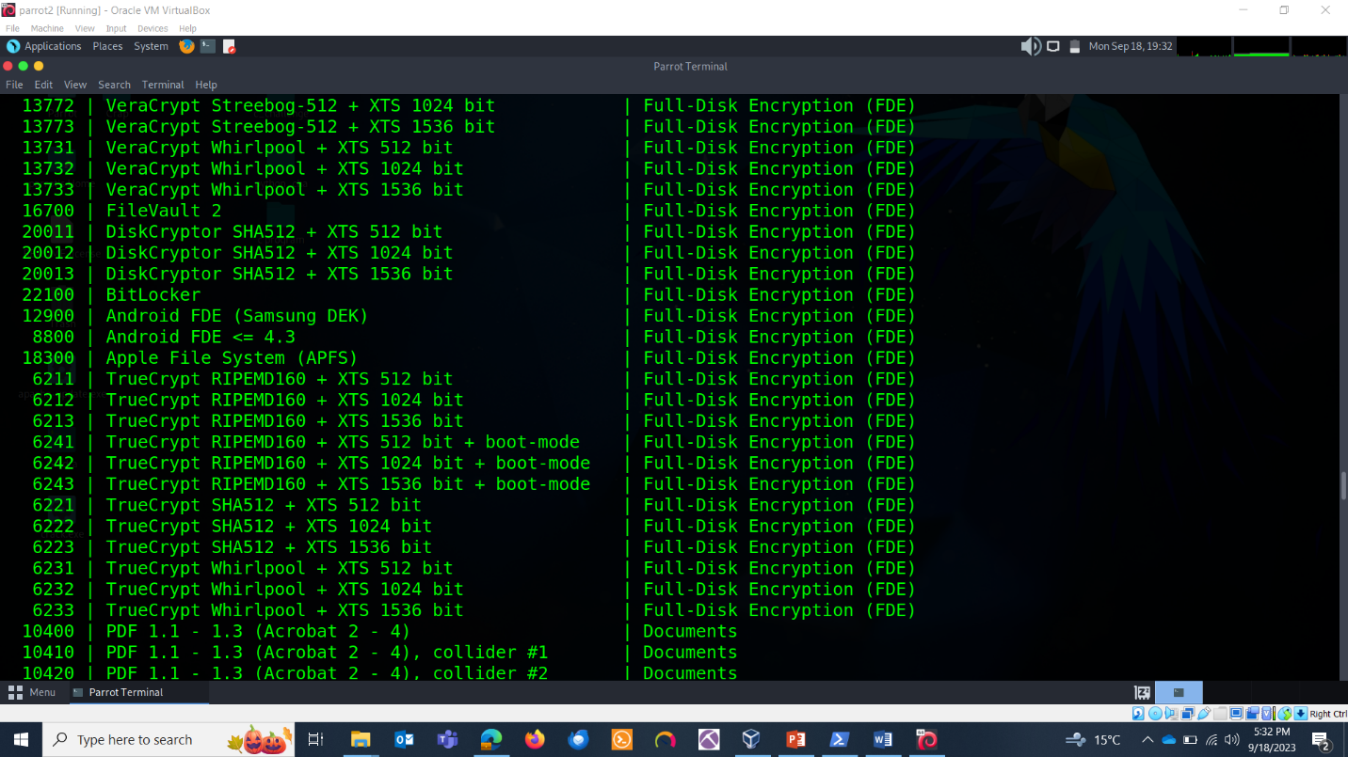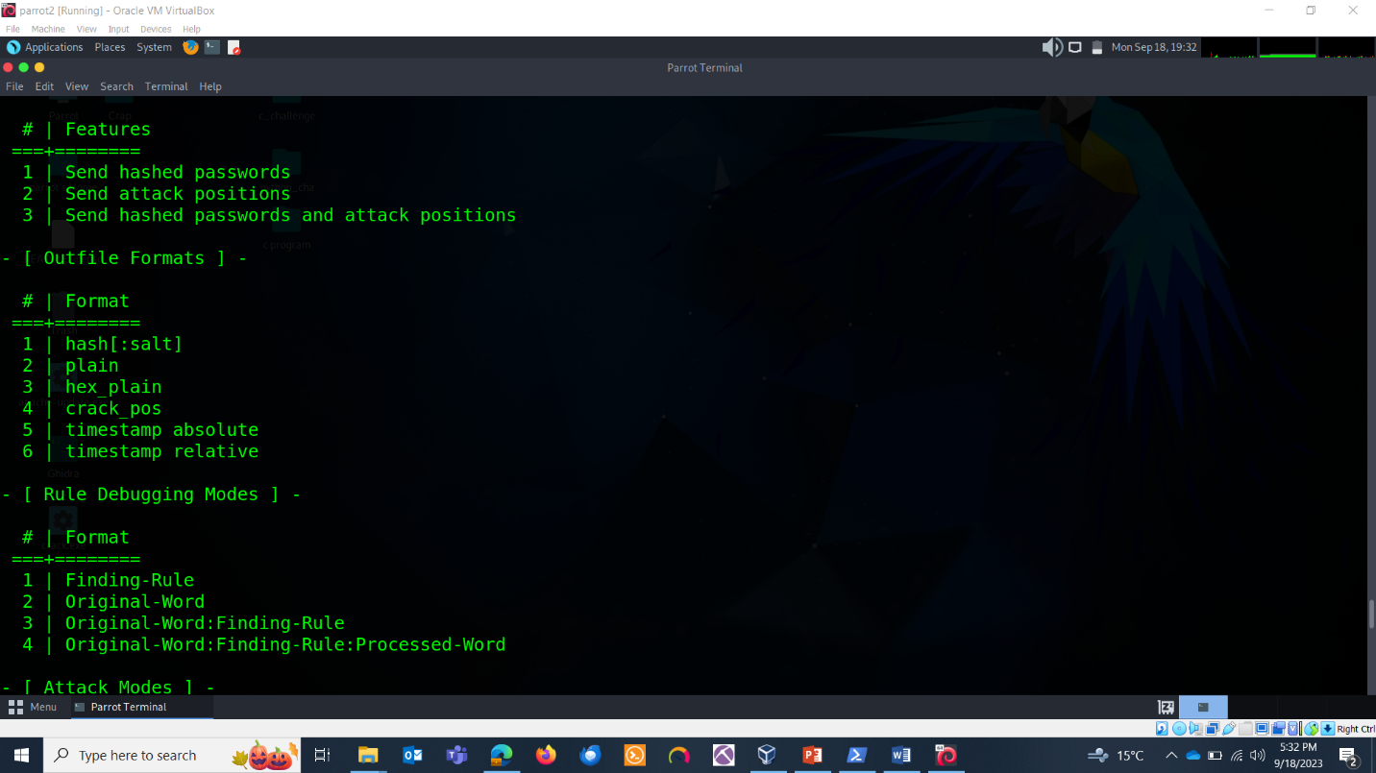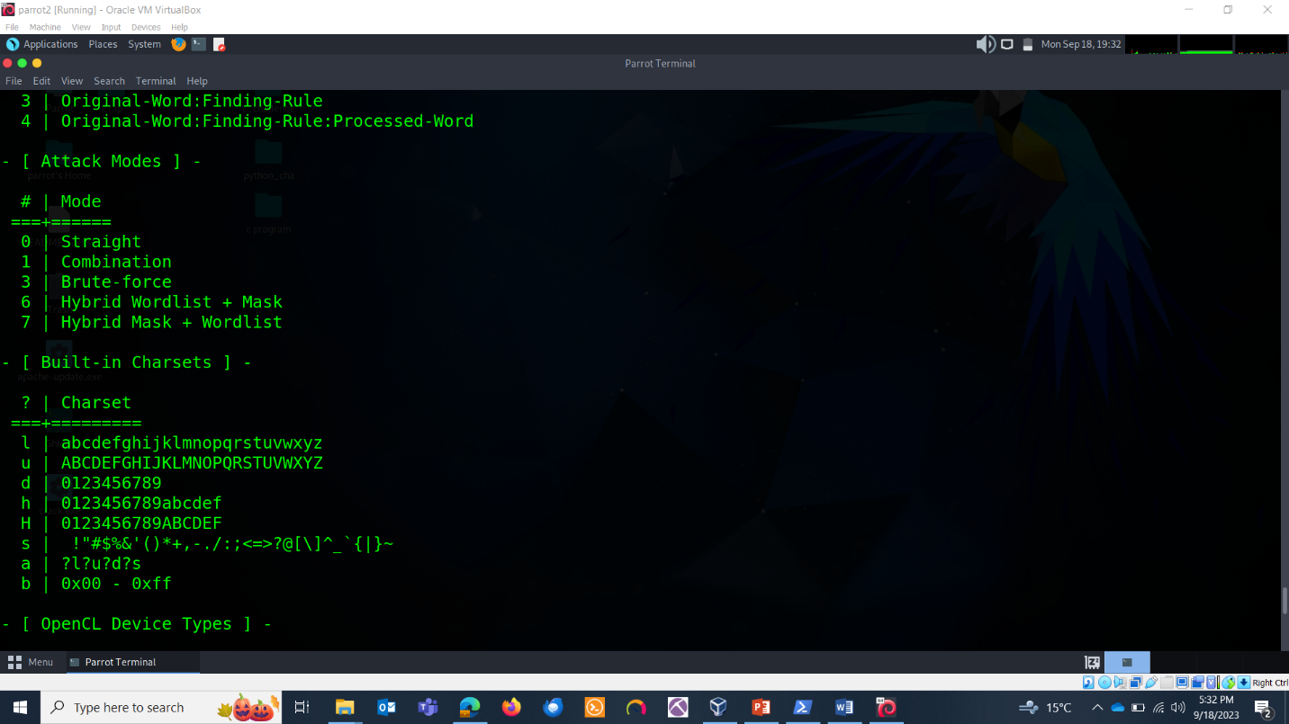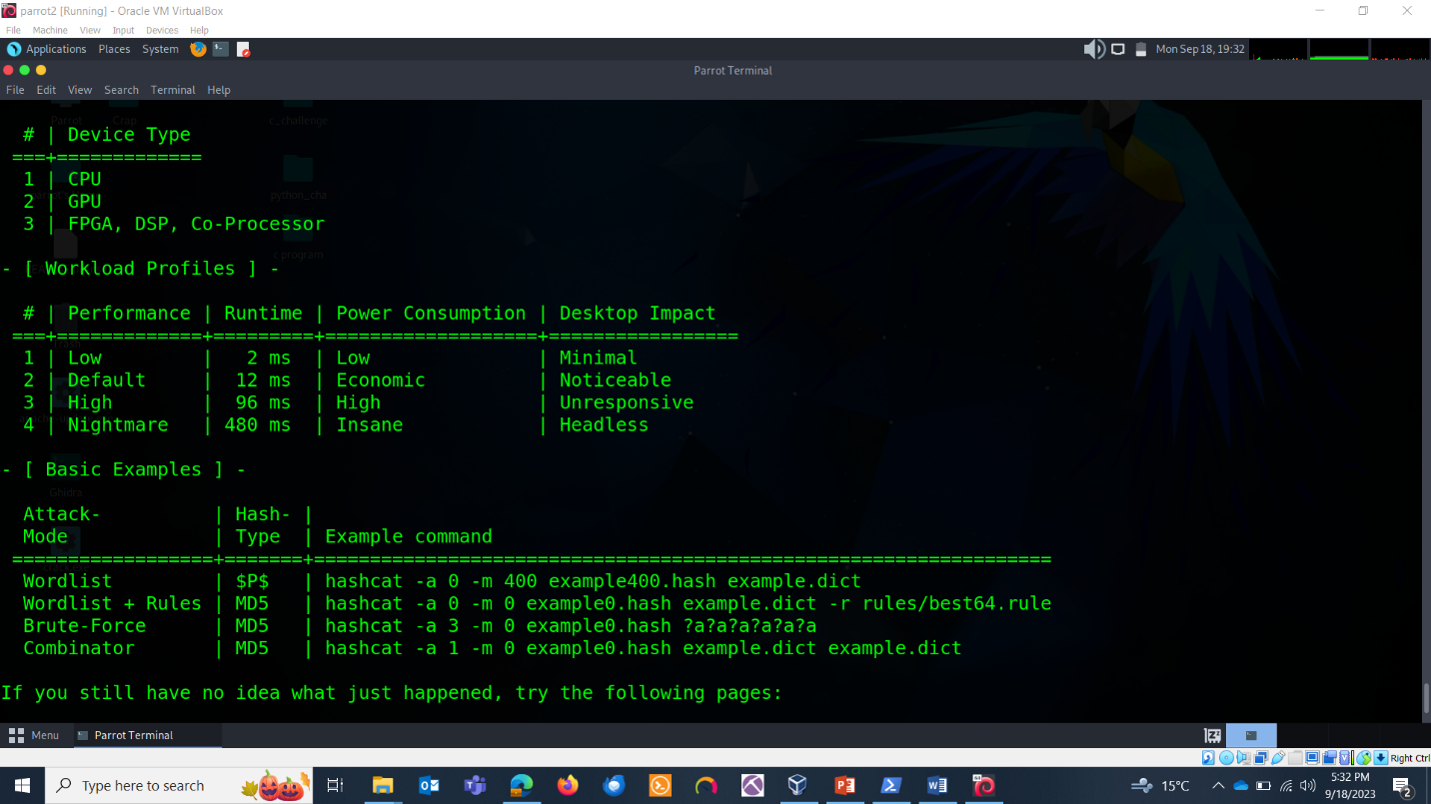

IDENTIFYING HASHES:

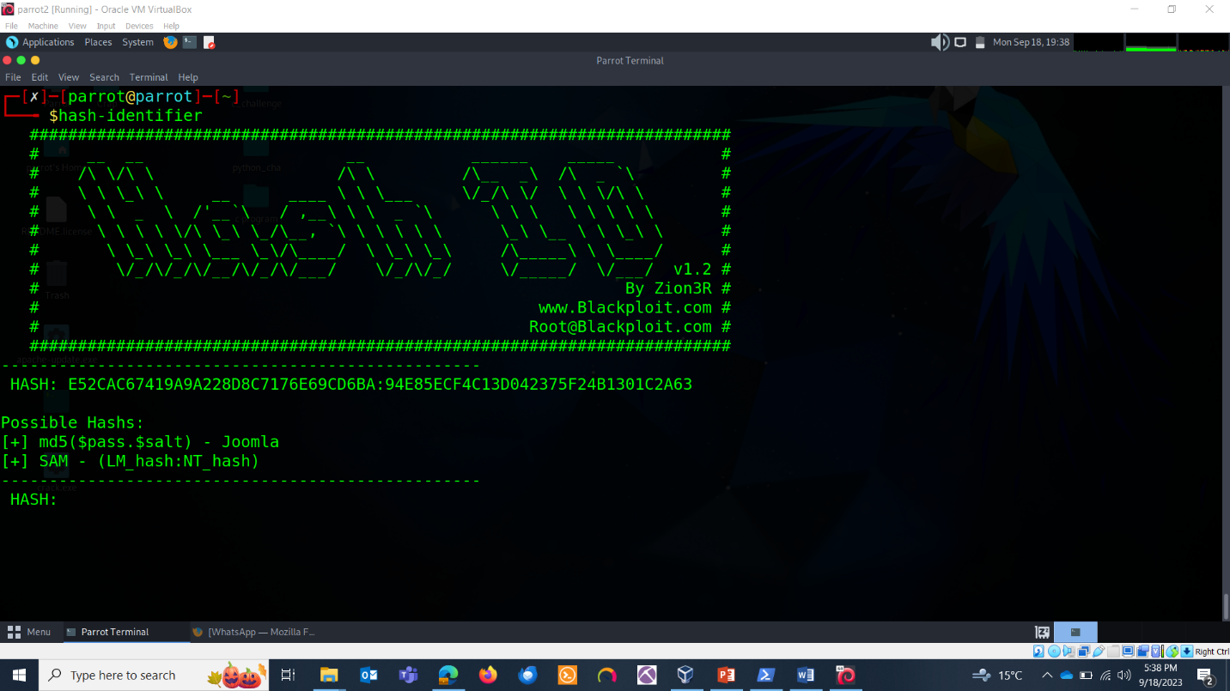

SAVING HASHES:

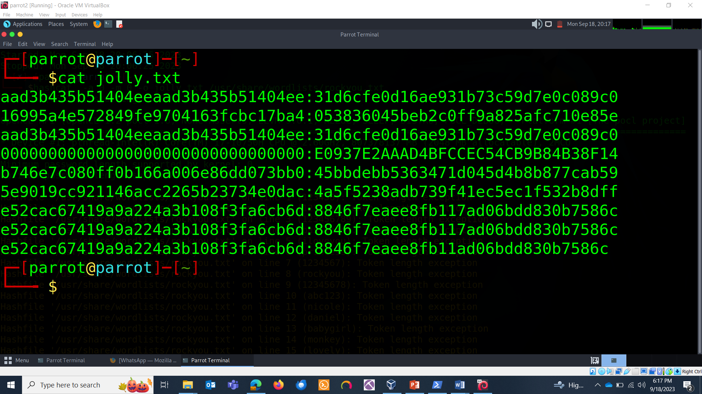

Running Hashcat:

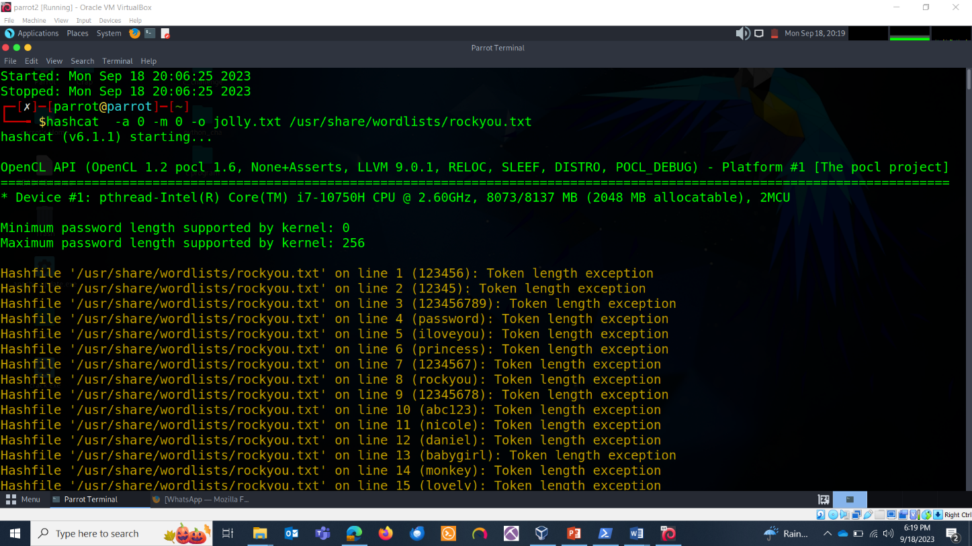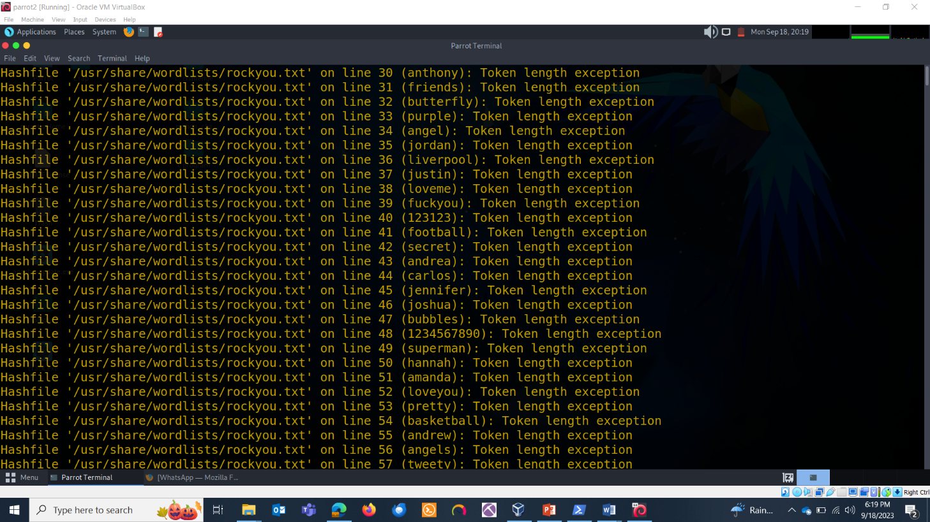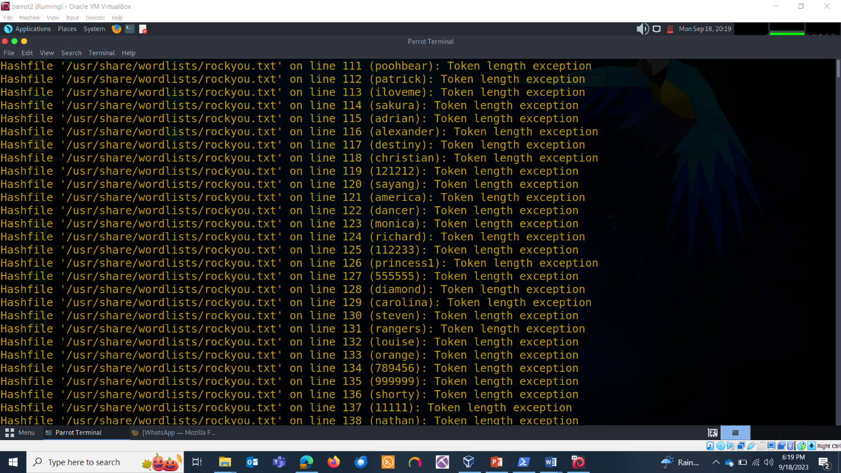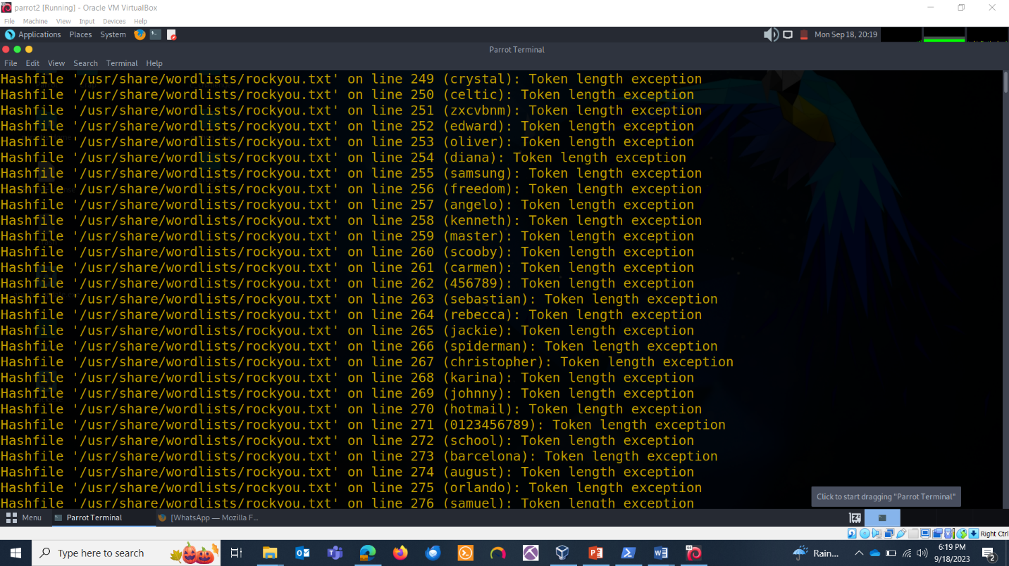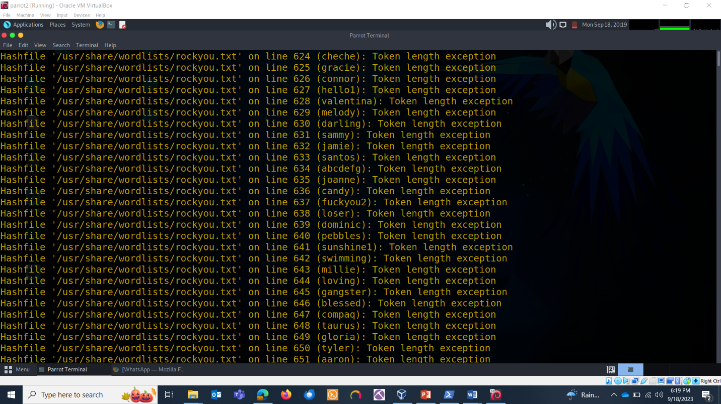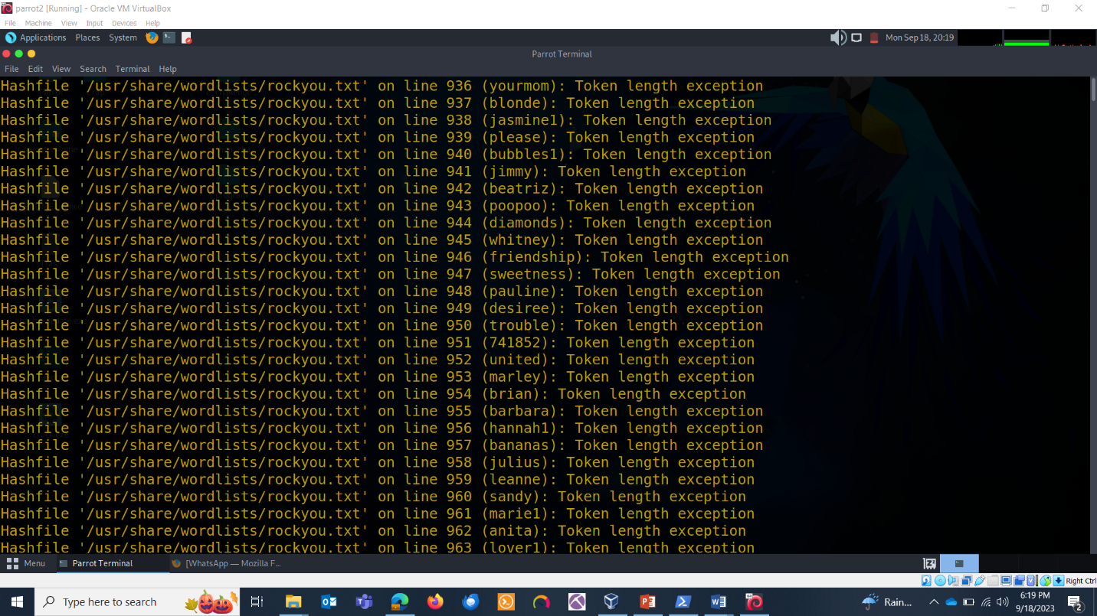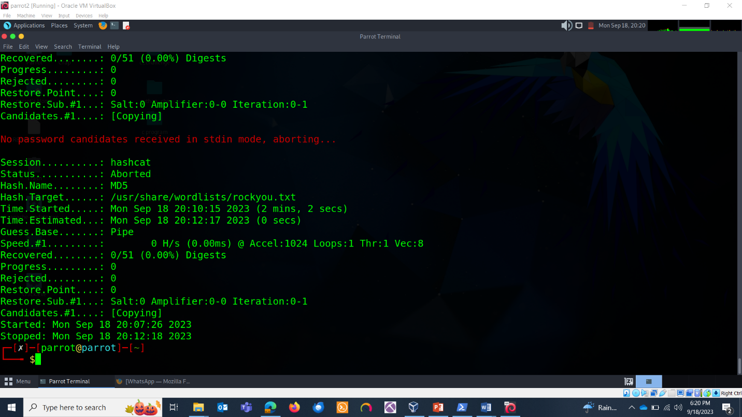

**JOHN-THE-RIPER:**

apt-get install john

john –update

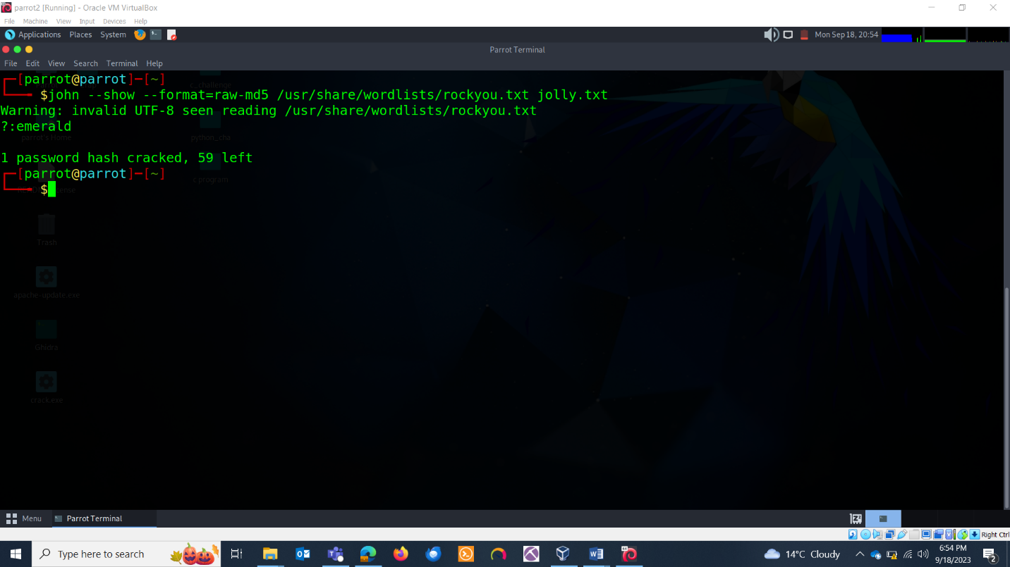

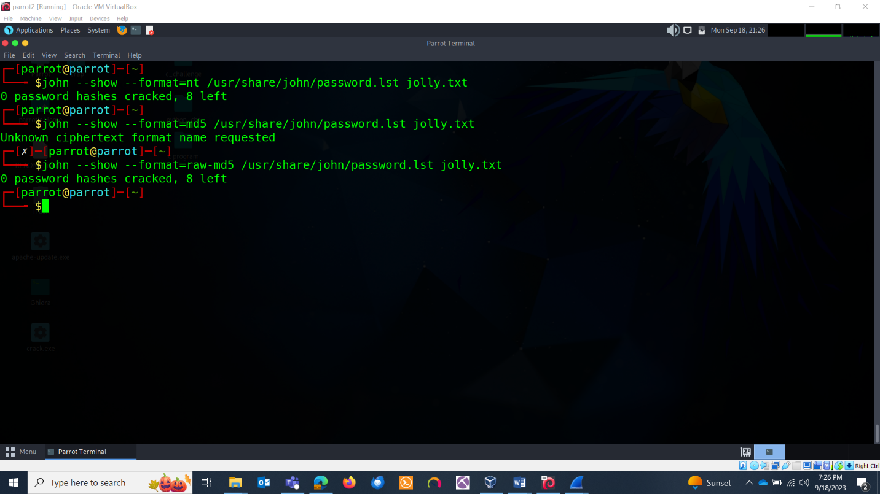

HASHES:

Administrator:JOHN-WINXP:E52CAC67419A9A228D8C7176E69CD6BA:94E85ECF4C13D042375F24B1301C2A63

BoyBoy:JOHN-WINXP:e52cac67419a9a224a3b108f3fa6cb6d:8846f7eaee8fb117ad06bdd830b7586c

Guest:JOHN-WINXP:aad3b435b51404eeaad3b435b51404ee:31d6cfe0d16ae931b73c59d7e0c089c0

AUSER:JOHN-WINXP:16995a4e572849fe9704163fcbc17ba4:053836045beb2c0ff9a825afc710e85e

George:JOHN-WINXP:aad3b435b51404eeaad3b435b51404ee:31d6cfe0d16ae931b73c59d7e0c089c0

JOHN-WINXP$:RSADEMO:00000000000000000000000000000000:E0937E2AAAD4BFCCEC54CB9B84B38F14

Harry:JOHN-WINXP:b746e7c080ff0b166a006e86dd073bb0:45bbdebb5363471d045d4b8b877cab59

Sam:JOHN-WINXP:5e9019cc921146acc2265b23734e0dac:4a5f5238adb739f41ec5ec1f532b8dff

Guest1:JOHN-WINXP:e52cac67419a9a224a3b108f3fa6cb6d:8846f7eaee8fb117ad06bdd830b7586c

Guest2:JOHN-WINXP:e52cac67419a9a224a3b108f3fa6cb6d:8846f7eaee8fb117ad06bdd830b7586c

Guest3:JOHN-WINXP:e52cac67419a9a224a3b108f3fa6cb6d:8846f7eaee8fb11ad06bdd830b7586c

ANALYSIS:

Guest3:JOHN-WINXP:e52cac67419a9a224a3b108f3fa6cb6d:8846f7eaee8fb11ad06bdd830b7586c

HASH EXPLANATION:

WINXP:e52cac67419a9a224a3b108f3fa6cb6d:8846f7eaee8fb11ad06bdd830b7586c

* WINXP is some identifier or label, which may indicate the operating system or the source of the hash.
* e52cac67419a9a224a3b108f3fa6cb6d is the first part of the hash, often referred to as the hash identifier or LM hash. This part typically represents the hash of the password (or a part of it).
* 8846f7eaee8fb11ad06bdd830b7586c is the second part of the hash, which is the NTLM hash. This part represents the hash of the password (or a part of it) in a different format.

The last part is the hash.

